GCSE Road Cycling

- Name the parts of the bike:
“Tops”
Stem
Frame
“Hood”
Saddle
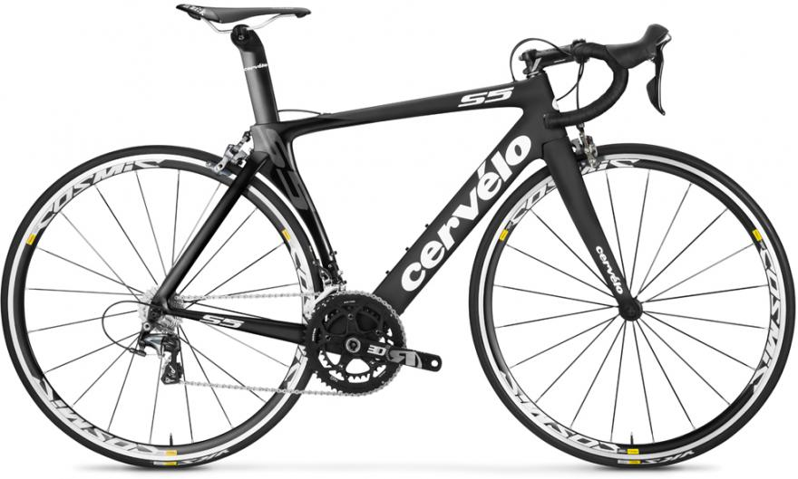
Brake + Shifter Lever
Seat Post
“Drops”
Rear Brake
Front Brake
Tyre
Cassette

Rim
Rear derailleur
Spoke
Crank Arm
Chainring
Jockey Wheels
Front derailleur

- What is meant by the term “cadence”?
Cadence is the speed at which the legs move. It is measured in RPM (revolutions per minute), i.e. the number of times a person’s pedal makes a full rotation in one minute.
- Why is it important in cycling? Hint: think of efficiency!
It is important as usually the higher the cadence, the less energy is needed to ride at the same speed. Basically, the faster your legs move, the easier it is. This is because your legs are not having to push as hard.
- When riding uphill (ascending) you need to consider different techniques and when they would be appropriate. Describe why you might remain seated and why you might stand: Hint: consider hill length and steepness!
Seated: Longer hills, less steep hills (shallower/lower gradient), more efficient, feels easier
Standing: Shorter hills to “sprint” up, steep hills (higher gradient), more power, easier acceleration, stretch your legs and back. Sometimes it’s nice to stand up so that you can move more freely to stretch out as when road biking you remain in the same position for long durations. Standing up “mixes” things up a bit and hills are a good time to do this.

- When ascending you may need to select a lower gear. Draw cross on the picture below when you should change gear and write why.
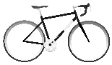
Top
Bottom
It is difficult to change gear uphill due to the increase of forces through the chain and gear system. This means that you need to change to a lower gear before you are on the hill. Otherwise you can end up “stuck” in a gear that is too high!

- When riding downhill (descending) what three things do you need to consider? Hint: think about where you are looking, body position and where to place your hands!
- Looking ahead you are travelling very fast and need to be able to spot hazards and make decisions before you reach them.
- Sitting further back in the saddle / leaning back in order to keep your centre of gravity in a neutral position between the two wheels. This means you can brake and corner properly.
- Cover your brakes with fingers so you can brake immediately if you need to. Think about which brake to use more, front or back?

- On the diagram below draw the fastest path (race-line) through the corner and write the appropriate speed you would take at each point of the corner. Medium, Fast, Slow.

Slow

Start
Finish

Medium

Fast

- Where should you be looking when cornering?
Towards the exit of the corner / as far around the corner you can see. This helps balance the bike and keep a smooth course. Avoids cornering “like a 50 pence piece”.

- As you ride around corners your feet need to raised or lowered to avoid striking the ground. This also helps you to ride the corner smoothly. Draw lines to match up each foot with the most appropriate statements.
Forcing body weight through the outside foot, helps to balance and move the bike when cornering.
Inside Foot | Lowered
 | Unweighted
Outside Foot | Raised
 | Press down

- What advantage is there in riding close behind another rider?
Drafting! Following closely behind another rider can save you up to 30% of effort. More riders in front of you gives you a bigger effect. (Research has also shown that having a rider behind you also gives you a 5% benefit. Needed in question 11)
- Draw cross on the rider below who gains the biggest advantage described in question 10.
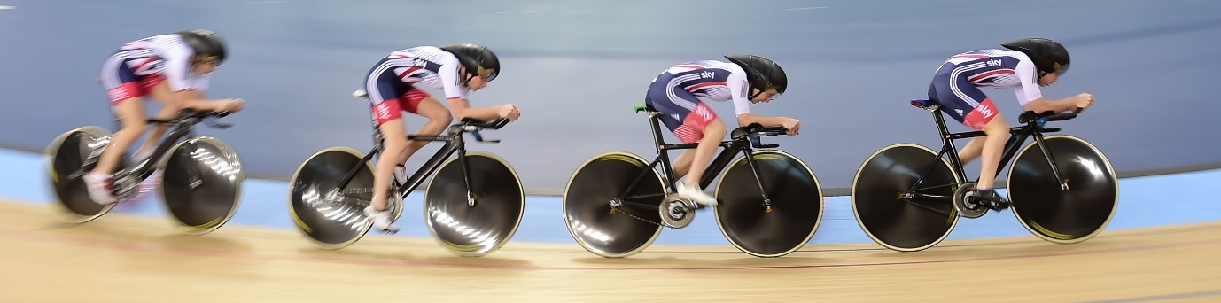
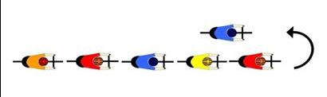
- In order to share this advantage riders in a group need to change their location in the group. Explain what is meant by “through and off”. You can draw a diagram to help.
In a single file line of riders (“train”), the person at the front peels off then slowly drifts to the back of the line. They then re-join the train at the back of the line. Repeating this “through and off” technique means that work on the front gets shared between all the riders in the train.

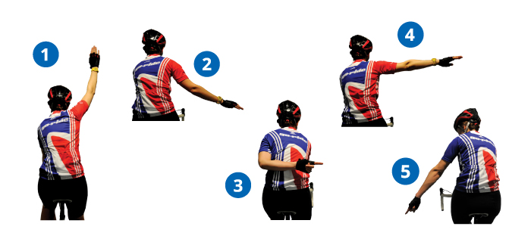
- In a large group, riders towards the back may not be able to see what is ahead. Different signals (hand and verbal) are used and get passed on down the group. Look at the diagram below and write what each signal means.

“Car up!”
“Car back!”

6
7

1. Stopping | 2. Slowing
3. Move out/ obstruction | 4. Indicating
5. Hazard / Pothole | 6. Car approaching
 | from the front
7. Car approaching
From behind

- Towards the end of a race riders will come to a “sprint finish” in order to use all of their energy to win. What four basic things do you need to do to sprint fastest? Hint: think about sitting or standing, body position, where your hands are!

- Look ahead need to focus on where you are going! Also helps bike control.
- Stand up much greater acceleration and power, can pump the pedals.

- Body forward and low allows you to put more bodyweight over the pedals and into each pedal stroke. Low body position improves aerodynamics and speed.

- Hold the drops this means you can get more leverage with your arms and you can pull the handle bars = more power. Also puts you into and even lower body position

- What is meant by the term “hold your line” and why is this essential in a sprint finish?
The term means for you to ride in a straight / predictable line. This is essential in sprint finishes as they are often very frantic and stops riders colliding together.

- Wind is an important factor in road cycling, why is this?
In normal conditions 80% of your effort on a bike is spent in pushing the air in front of you out of the way. The force felt in moving air out of the way is called air resistance. Wind affects the air resistance felt when cycling. Riding into a headwind increases air resistance, a tailwind reduces it.
Side winds slightly increase air resistance but massively affect bike stability and cornering. (blowing you across the road etc.)

- Imagine you are in race riding into a strong headwind. Where might you want to position yourself in a group of riders in order to conserve the most energy?
At the back. In order to shelter yourself from the increased air resistance.

